Step-1: Extract the zip file and go to the codes directory and add the project directly to the eclipse by browsing the file where you unzip the Final project Group-5.

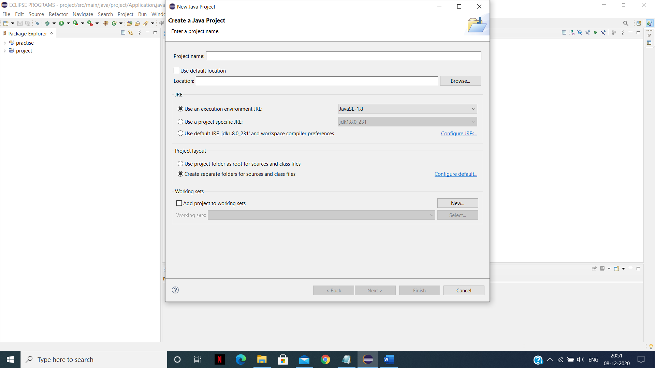

Step-2: secondly go to the src/main/java in that project under that you see the codes for three methods shown in the screen shot.

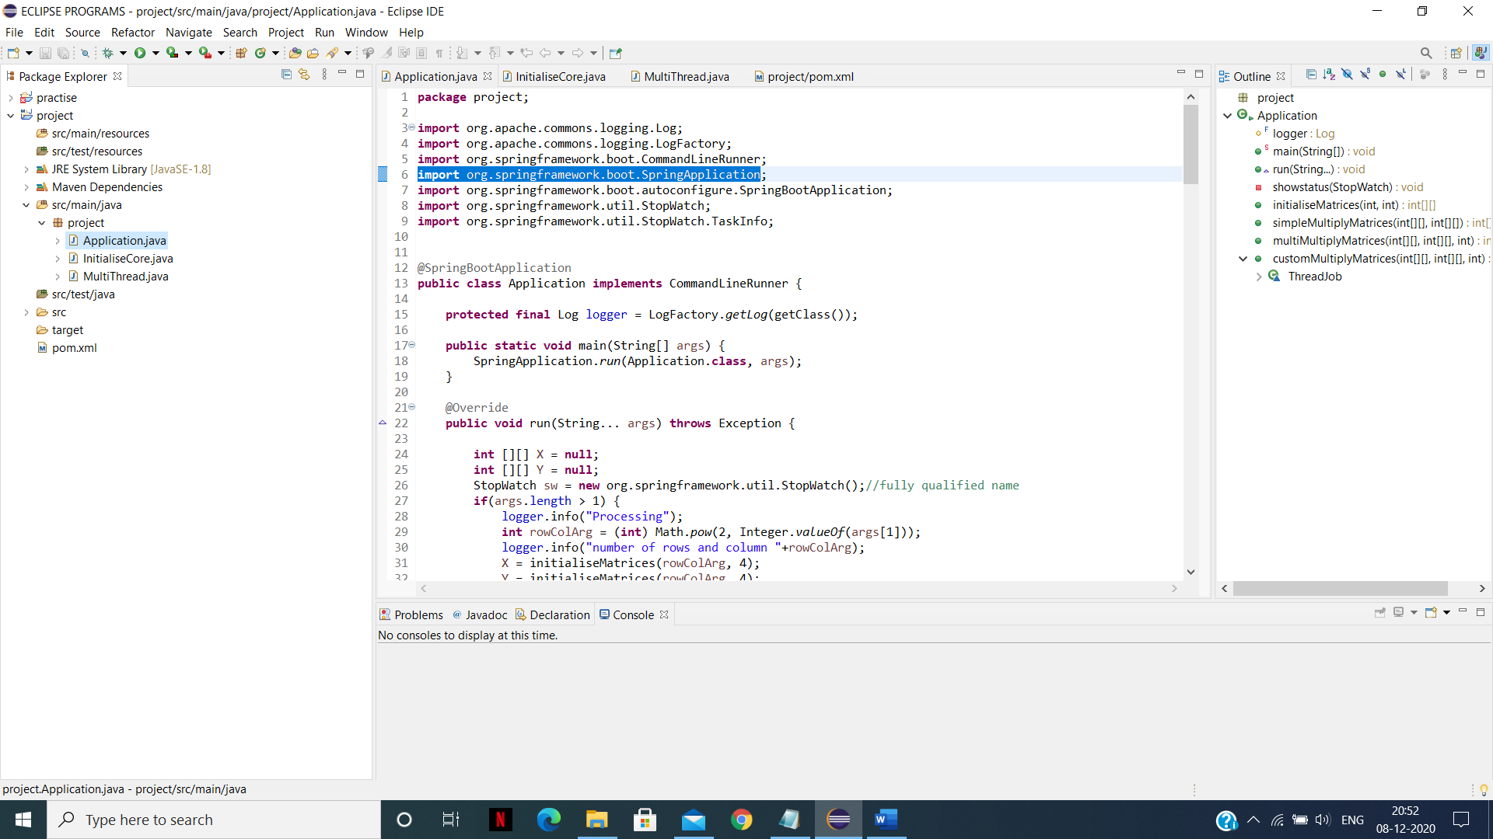

Step-3: Thirdly the methods all three developed in java and assigning the values in matrix I created an object initialization core and multithread whereas last method extend thread.pom.xml for spring boot framework.

Step-4:running the application for debugging and execute the results.

Go to the applicationjava right click on the code go to the Runas in that run configuration it opens another window in that no need to change the setting keep like that then go to the arguments and apply size of the matrix and then apply and then it the run command observe the execution results in the console as observed in the screenshot below:

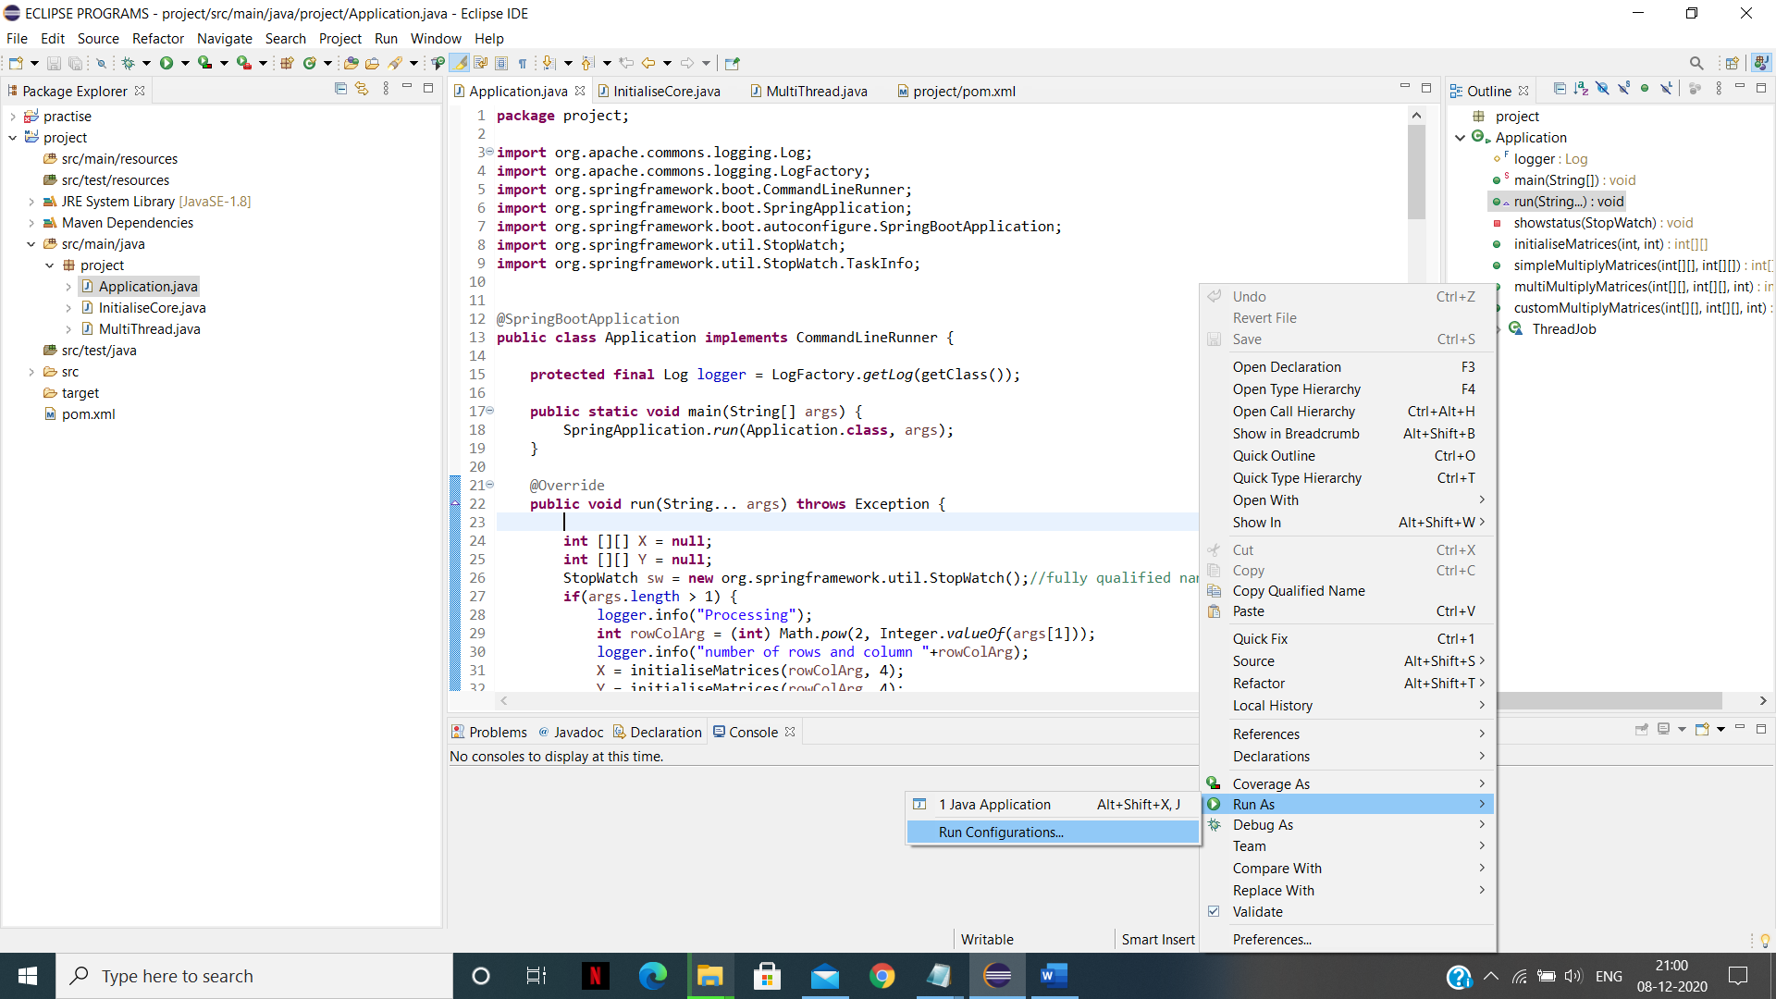

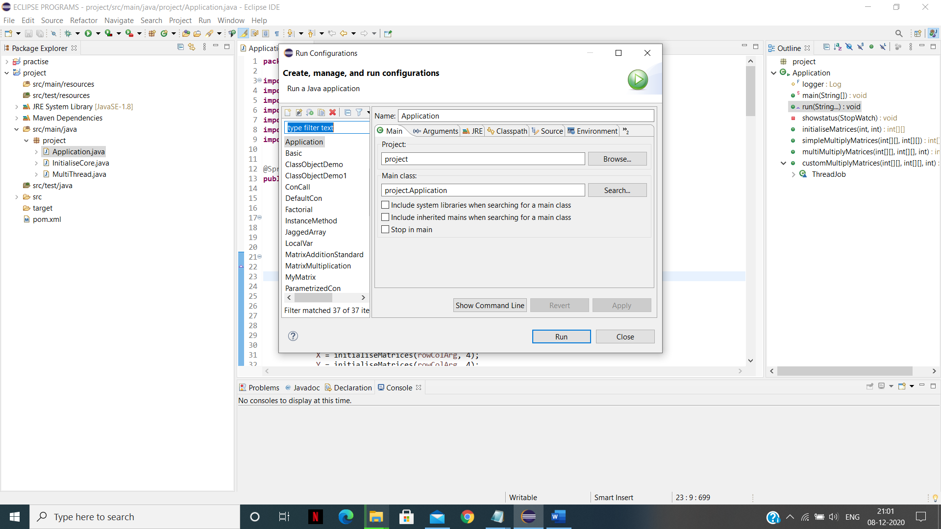

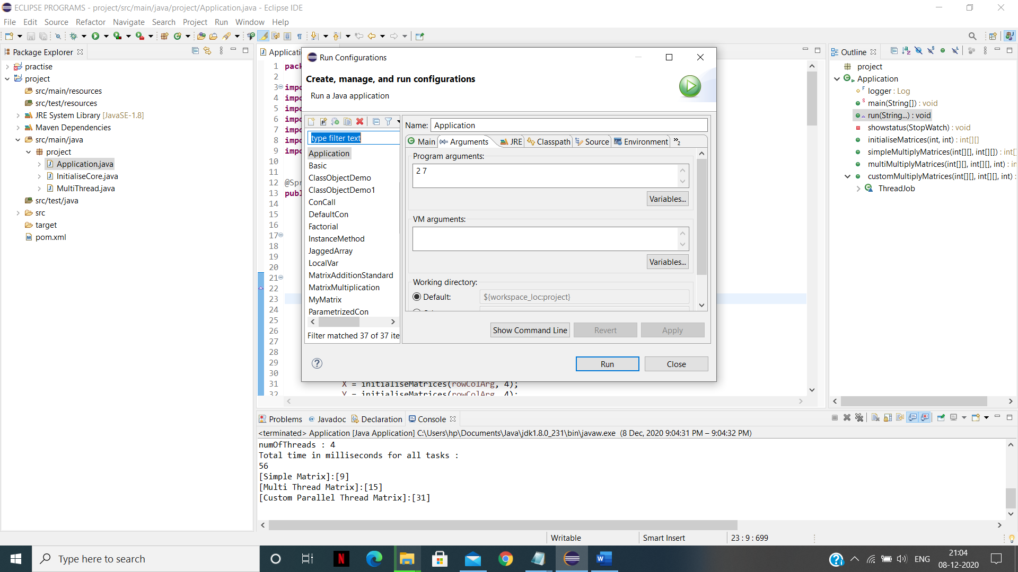

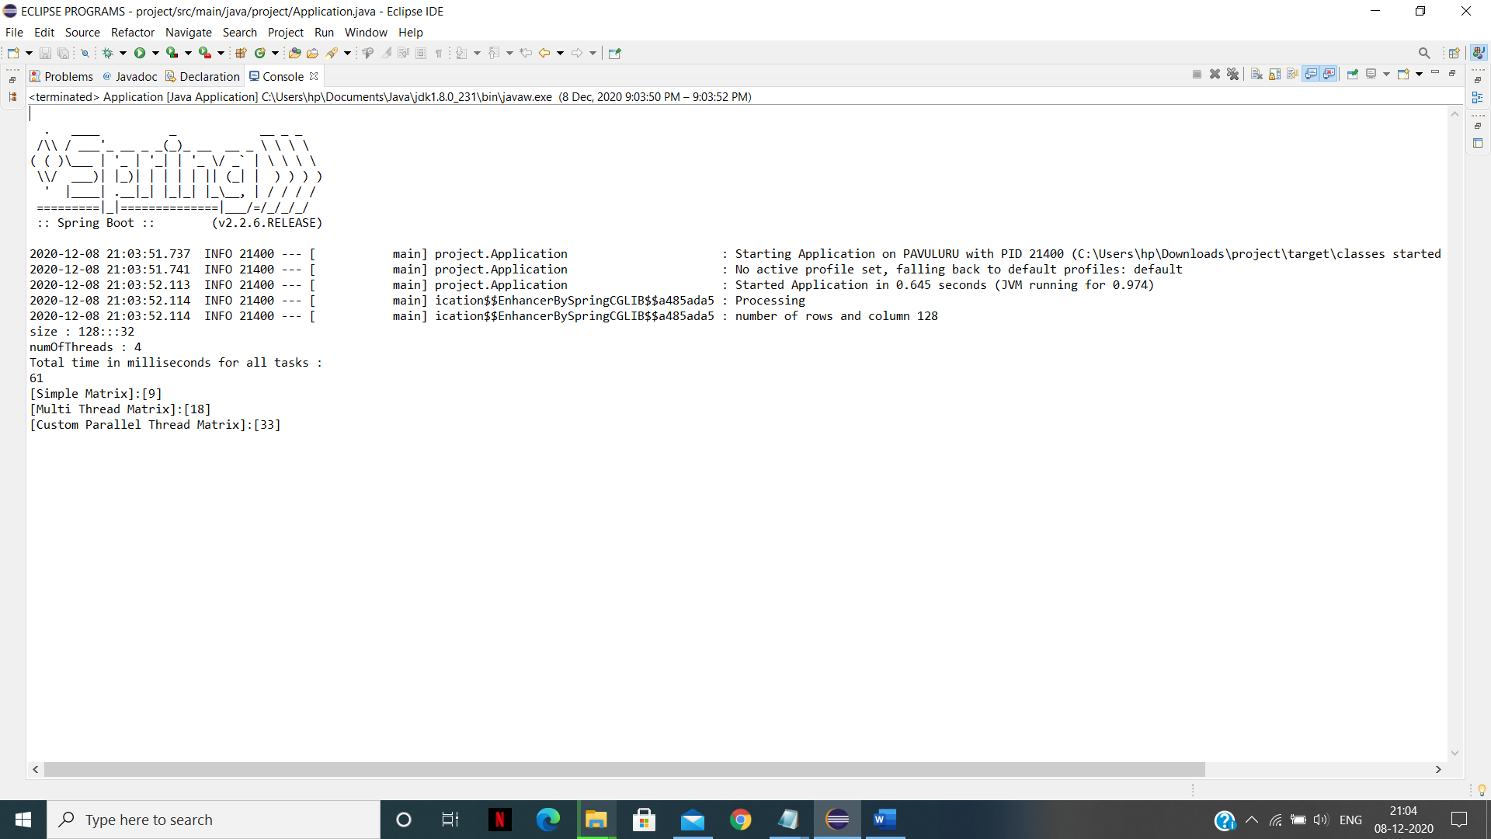

Note: Algorithm is clearly explained in the word document of final report.